Nicholas Ionata

Dr. Brown

CEN3031

7 February 2019

Mapping the MEAN Stack

File Hierarchy

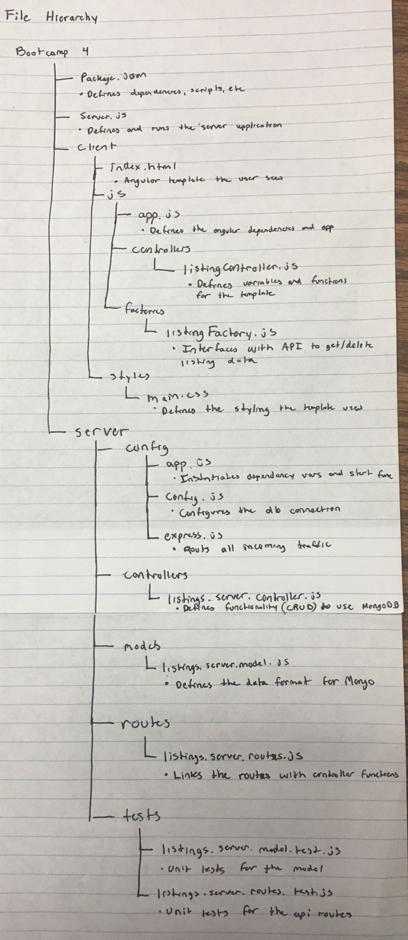

Front-end to Back-end Data Flow

